1.

2.

3.

Question 1: What are the primary function of graphics in a report?

Graphics are used to demonstrate logic and numerical relations clearer.

Graphics can deliver communicate spatial information in a more effective way.

Graphics are good at communicating steps in a process

Graphics can save space.

Question 2: How does one know that a graph is being used effectively?

An effective graphic meets five principles, one can check whether these five are satisfied to tell how effectively the graph is being used.

1. An effective graph should serve a purpose.
2. An effective graph should be simple and uncluttered.
3. An effective graph should present a manageable amount of information.
4. An effective graph should meet readers’ format expectations.
5. An effective graph should be clearly labeled.

Question 3: Where does the use of a graphic have the most impact? Cite a specific example, including a link.

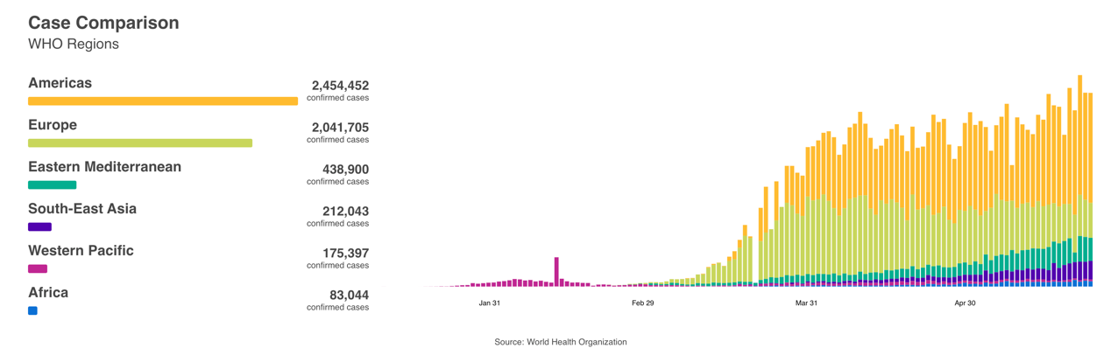

Figure 1 COVID-19 Case Comparison

WHO coronavirus disease (COVID-19) dashboard. Geneva: World Health Organization, 2020. Available online: <https://covid19.who.int/>

This graph provided by World Health Organization present readers with the COVID-19 total case comparison among 6 continents. This is a novel bar graph containing two parts which effectively delivers information to readers by means of color usage and its clear logic. As is labeled clearly, the left part shows the current confirmed cases in six continents. The order of those continents is according to the rank of confirmed cases, which shows a clear logic. The right part integrates the information presents on the left side to one column, and put them along the time axis. This provides readers a clear information of the total confirmed cases changes throughout time. The other feature is the color usage, this graph uses distinguishable color representing each continent to emphasize the comparison. In conclusion, the logic and color usage are clear and effective, making this graph more impressive.